
AN INTERNSHIP REPORT
Submitted by

MANOJ KUMAR D - 412422205084
In Partial fulfillment for the award of the degree of
BACHELOR OF TECHNOLOGY
in
INFORMATION TECHNOLOGY
SRI SAI RAM INSTITUTE OF TECHNOLOGY (AUTONOMOUS),
SAI LEO NAGAR, CHENNAI-44

ANNA UNIVERSITY : CHENNAI 600 025
JULY - 2024

BONAFIDE CERTIFICATE
Dr. S. RAJARAJAN, PROFESSOR  DEAN ACADEMICS | Dr. V. BRINDHA DEVI,  PROFESSOR, HOD, CAPTAIN
Mr.R.SAMPATH,  PROFESSOR, STRATEGIST | Mrs. JOSEPHINE RUTH FENITHA  AP, ORGANIZER
Mrs. C. VALARMATHI  AP, PROPAGATOR | Ms.R. SHOBANA LAKSHMI  AP, INTERNSHIP COORDINATOR
Certified that this internship report as “DATA SCIENCE” are the Bonafide works of “ MANOJ KUMAR D - 412422205084” who carried out the internship works in the “Chennai Unified Metropolitan Authority (CUMTA) ” .

Mr.P. SUTHAHAR
AP, EXECUTOR

Submitted for project Viva – Voce Examination held on _ _ _ _ _ _ _ _ _ _ _ _ at Sri Sai Ram Institute of Technology, Chennai - 600044

DETAILS OF INTERNSHIP

SECTION NUMBER | COMPANY NAME | MODE OF  INTERNSHIP | YEAR / SEM
I | Chennai Unified Metropolitan Authority (CUMTA) | HYBRID | III/ V

TABLE OF CONTENTS

S. NO. | TITLE | PAGE NO.
1. | ABSTRACT | 1
2. | ABOUT THE COMPANY | 2
3. | ABOUT THE INTERNSHIP  3.1 OBJECTIVE  3.2 MOTIVATION | 3  4
4. | SECTION I  DASHBOARD CREATION FOR TRAFFIC COUNT THROUGH CCTV  - PROPOSED SOLUTION  - DESIGNED METHODOLOGY  - FEATURES  - PROTOTYPE  - REQUIREMENTS | 5
 | SECTION II  DASHBOARD CREATION FOR TAFFIC MONITOR BY TABLEAU  - PROPOSED SOLUTION  - DESIGNED METHODOLOGY  - FEATURES  - PROTOTYPE | 9
 | SECTION III  IMAGE ANNOTAION FOR VEHICLE DETECTION IN ROBOFLOW  - PROPOSED SOLUTION  - DESIGNED METHODOLOGY  - FEATURES  - PROTOTYPE | 13
 | SECTION IV  DATA MANIPULATION AND CLEANING OF TRIRUVANNAMALAI BUS DEPO  - PROPOSED SOLUTION  - DESIGNED METHODOLOGY  - FEATURES | 18
5. | IMPACT OF THE INTERNSHIP | 19
6. | PROOF OF COMPLETION | 20
7. | RESULT AND CONCLUSION | 21

CHAPTER - 1 ABSTRACT
This internship report outlines the work carried out at Chennai Unified Metropolitan Transport Authority (CUMTA), focusing on data manipulation, dashboard creation, backend development, and image annotation. The project aimed to assist CUMTA in managing and analyzing urban traffic data, leveraging their existing infrastructure for collecting vehicular movement statistics through CCTV cameras. Each component of the project contributed to building a comprehensive solution for traffic monitoring.
The first phase of the internship involved data manipulation using Jupyter Notebook. I worked on cleaning and preprocessing a dataset from the Tiruvannamalai Bus Depot. This involved handling missing values, removing redundant entries, and standardizing data formats, ensuring that the dataset was ready for analysis.
Next, I worked on Tableau to create an interactive dashboard for the EGA Theatre Signal, which displayed vehicle count data. Using Tableau's dynamic charting capabilities, I visualized the vehicle counts over time and by direction, allowing traffic management teams to better understand vehicle flow at the signal. This dashboard incorporated line charts, bar charts, and heatmaps, making it easy to interpret the data for decision-making.
The core of the project involved backend development using Flask. I developed a series of APIs to serve vehicle count data, which was stored in a MongoDB database. The APIs were designed to handle requests for vehicle counts, types, and time-series data. The backend was containerized using Docker for easy deployment and scalability.
Finally, I worked on image annotation using Roboflow for labeling vehicle types. This involved annotating images of various vehicles—such as ambulances, autos, bikes, buses, and pedestrians—creating labeled datasets that can be used for machine learning tasks like vehicle detection. The labeled dataset will assist in developing more advanced solutions for automated traffic monitoring.
While the project is still in its development phase, the work completed during the internship has laid the foundation for a robust, scalable tool to assist CUMTA in managing urban traffic data. This report outlines the technical challenges, the technologies employed, and the contributions made during the internship.
CHAPTER - 2 ABOUT THE COMPANY

NAME OF THE COMPANY : Chennai Unified Metropolitan Authority (CUMTA)

CIN NUMBER : 33AAALC2073J127

CUMTA is the nodal agency that brings together all the agencies working in the area of urban transport in Chennai, to ensure the seamless delivery of mobility services across various modes such as bus, metro, rail, walking and cycling.
With CUMTA, creating transport systems becomes integrated, collaborative, and most importantly, more efficient. CUMTA promotes, oversees, coordinates, and monitors the implementation of various transport and traffic measures in the Chennai Metropolitan Area (CMA)
- To function as an Institutional coordination mechanism across various agencies involved in Urban Mobility
- To manage the urban transport system within CUMTA jurisdiction through strategic planning, ensure project implementation, overseeing operation and management, regulatory functions, funding and research studies and awareness.
- To regulate measures that would help to reduce the incidence of accidents and other matters relating to safety.

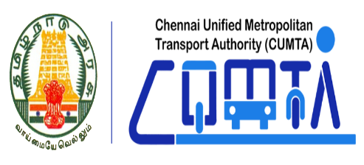
Title of the Internship : WEBSITE DEVELOPER
Internship Period: 01/06/2024 to 30/08/2024 (90 Days)
Mode of Internship: HYBRID

CHAPTER - 3

ABOUT THE INTERNSHIP
3.1 OBJECTIVE
The primary objective of the internship at Chennai Unified Metropolitan Transport Authority (CUMTA) was to contribute to the development of a comprehensive system for monitoring and analyzing urban traffic data. The goal was to leverage CUMTA’s existing data infrastructure, specifically CCTV systems, to provide real-time insights into vehicular movement at specific traffic signals. The project aimed to improve traffic management by automating the analysis and visualization of traffic data, providing decision-makers with actionable insights.
The first task of the internship was data manipulation. I worked on cleaning and preprocessing a dataset from the Tiruvannamalai Bus Depot. This involved handling missing values, removing duplicates, and standardizing data formats to ensure accuracy and consistency in the dataset. The clean data was then used for further analysis and visualization, allowing CUMTA to make informed decisions based on reliable information.
The next phase involved creating an interactive dashboard using Tableau. The dashboard was designed to visualize the vehicle count data collected at various traffic signals, enabling traffic management authorities to track vehicle flow and monitor congestion. Using dynamic charts like bar charts, line charts, and pie charts, the dashboard made it easier for CUMTA to analyze the data. By visualizing the traffic data in a user-friendly manner, the project aimed to help administrators and users interpret the data effectively for better decision-making.
The core of the project also involved backend development using Flask. I developed a set of APIs to retrieve, process, and serve traffic data stored in a MongoDB database. These APIs were optimized for performance to ensure efficient data retrieval and quick response times. The backend also included a role-based authentication system, which allowed administrators to manage users and control access to the dashboard, while regular users could only view traffic data and analytics. The backend was containerized using Docker to ensure scalability and ease of deployment.
Lastly, I worked on image annotation using Roboflow to label vehicle types in images collected from traffic cameras. This involved categorizing vehicles into different classes such as ambulances, buses, bikes, and pedestrians. The labeled data will be used to train machine learning models for automated vehicle detection, which can enhance CUMTA’s ability to monitor traffic without manual intervention.
3.2 MOTIVATION
The motivation to pursue this internship was driven by the opportunity to work on real-world projects that involved large-scale data management and the development of robust backend systems. The focus on optimizing data workflows, improving system scalability, and providing actionable insights aligned with my interest in how data can be leveraged to solve complex problems. This internship presented the chance to gain practical experience in data cleaning, backend system design, and real-time data processing—skills essential for building scalable solutions to meet the growing demands of data-driven applications. The opportunity to contribute to projects that enhance efficiency and decision-making processes in diverse sectors was an important factor in choosing this internship.The variety of tasks involved, ranging from database management and dashboard creation to backend optimization, provided an exciting opportunity to expand my technical skill set. I was particularly drawn to the challenge of integrating data manipulation techniques with backend services to create seamless, efficient systems capable of handling large datasets. Additionally, the chance to work on real-time data insights through tools like Tableau and develop scalable backend services allowed me to apply my knowledge in a way that directly addressed real-world challenges faced by organizations reliant on data for strategic decision-making. This hands-on work, combined with exposure to modern technologies like Docker, made the internship both intellectually rewarding and professionally fulfilling.
CHAPTER – 4

SECTION I
DASHBOARD CREATION FOR TRAFFIC COUNT THROUGH CCTV
4.1 PROPOSED SOLUTION
The proposed solution aimed to enhance data management and analysis efficiency across multiple domains, particularly transportation. Key tasks included automating data workflows for cleaning and structuring large datasets, enabling more accessible and accurate data. Interactive dashboards were created using Tableau to provide real-time insights into vehicle counts, facilitating better decision-making. Backend services were developed with Python to handle data processing, and scalable database management systems like PostgreSQL and MongoDB were implemented for efficient data storage and retrieval. To ensure system portability and scalability, Docker was used for containerizing applications, streamlining deployment, and enhancing overall performance. This solution integrated multiple technologies to create an efficient, scalable system for real-time data-driven decision-making.

4.2 DESIGNED METHODOLOGY
- Requirement Analysis: Gathering and understanding the needs of CUMTA's requirements for data visualization and user management.
- System Architecture Design: Backend (Python Flask), and database for scalability.
- Backend Development: Implementing APIs using Flask to connect the database with the frontend securely.
- Database Design: Setting up a relational database to store vehicle count data and user credentials securely.

4.4 PROTOTYPE

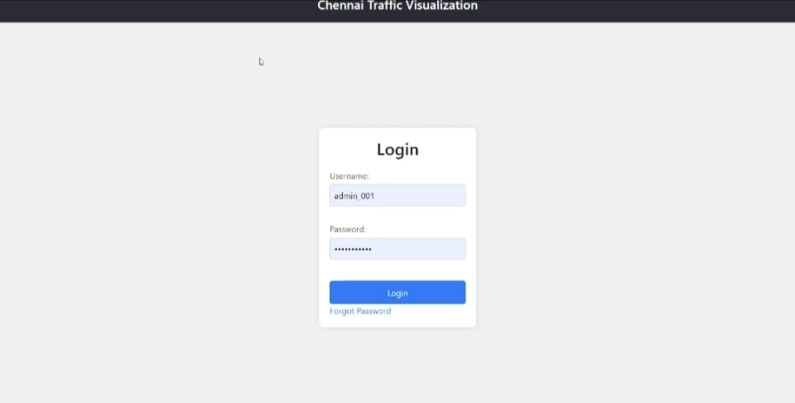
x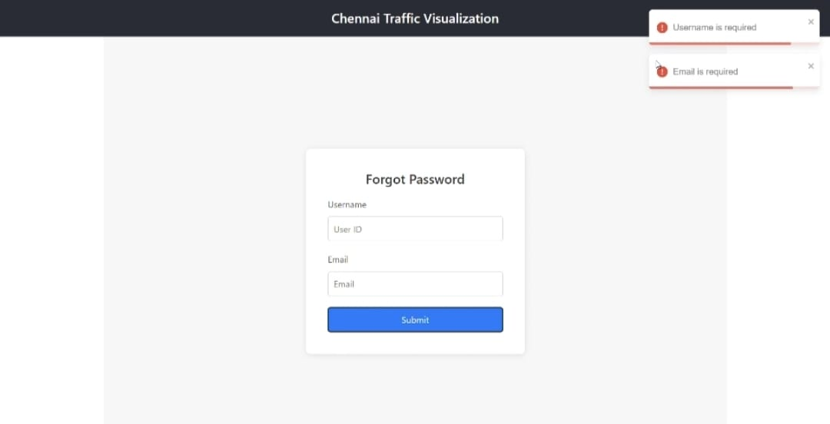

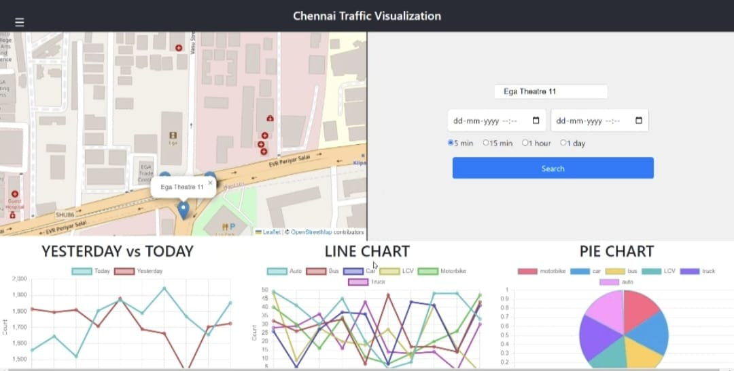
4.5 REQUIREMENTS:
Backend
Software Requirements
Backend: Python Flask.
- Database: PostgreSQL and MongoDB for data storage.
- Development Tools: VS Code, Postman for API testing, Git for version control.
- Containerization:Docker.
Data Requirements
- Traffic data collected by CUMTA from CCTV cameras.

SECTION II
DASHBOARD CREATION FOR TAFFIC MONITOR BY TABLEAU
Proposed Solution
To address the need for monitoring and analyzing vehicle traffic data effectively, a dynamic dashboard was developed using Tableau for the EGA Theatre Signal. This dashboard visualizes data collected from three cameras installed at the traffic signal and stored in a PostgreSQL database. The primary goal was to represent traffic patterns and vehicle counts based on timestamps, enabling stakeholders to make informed decisions for traffic management.
The dashboard leverages visual elements such as pie charts, bar graphs, and line charts to display the distribution and trends of vehicle counts across various categories, such as ambulance, auto, bike, bus, and car. This visualization facilitates real-time insights into traffic density and signal performance.

Designed Methodology
- Data Extraction:
  - Connected Tableau directly to the PostgreSQL database containing vehicle count and timestamp data.
  - Imported relevant data fields, including:
    - Signal Name
    - Camera ID (from the three cameras)
    - Vehicle Count (by type: ambulance, auto, bike, etc.)
    - Timestamp
- Data Preparation:
  - Aggregated the data to calculate total vehicle counts by type for each timestamp.
  - Used SQL queries to group data by camera ID, vehicle type, and time intervals (e.g., hourly or daily).
  - Cleaned the dataset in Tableau to handle missing or duplicate entries and ensure accurate visualizations.
- Dashboard Design:
  - Created multiple visualizations tailored to different analytical needs:
    - Pie Chart: Represented the proportional distribution of vehicle types for a specific time range.
    - Bar Chart: Showed the total count of each vehicle type, allowing easy comparison.
    - Line Chart: Illustrated traffic trends over time, highlighting peak hours and traffic patterns.
  - Combined these charts into an interactive dashboard with filters for:
    - Camera ID
    - Timestamp range
    - Specific vehicle types
- Interactivity and User Features:
  - Added filters and dropdown menus to enable users to explore specific datasets, such as vehicle counts for a particular camera or time period.
  - Incorporated tooltips to display detailed information for each data point on the charts.

Features
- Real-Time Traffic Insights:
  - The dashboard updates dynamically, pulling live data from the PostgreSQL database, ensuring real-time monitoring of vehicle counts.
- Comprehensive Visualization:
  - Pie, bar, and line charts provide multiple perspectives on the data, from overall distribution to detailed time-based trends.
- Multi-Camera Analysis:
  - Data from the three cameras at EGA Theatre Signal can be analyzed individually or collectively, enabling a granular view of traffic patterns.
- User-Friendly Interface:
  - Filters and dropdowns allow users to tailor the dashboard view based on their analytical requirements.
- Signal-Based Analysis:
  - The dashboard highlights traffic patterns specific to the EGA Theatre Signal, aiding in localized decision-making.

- 4.4 PROTOTYPE
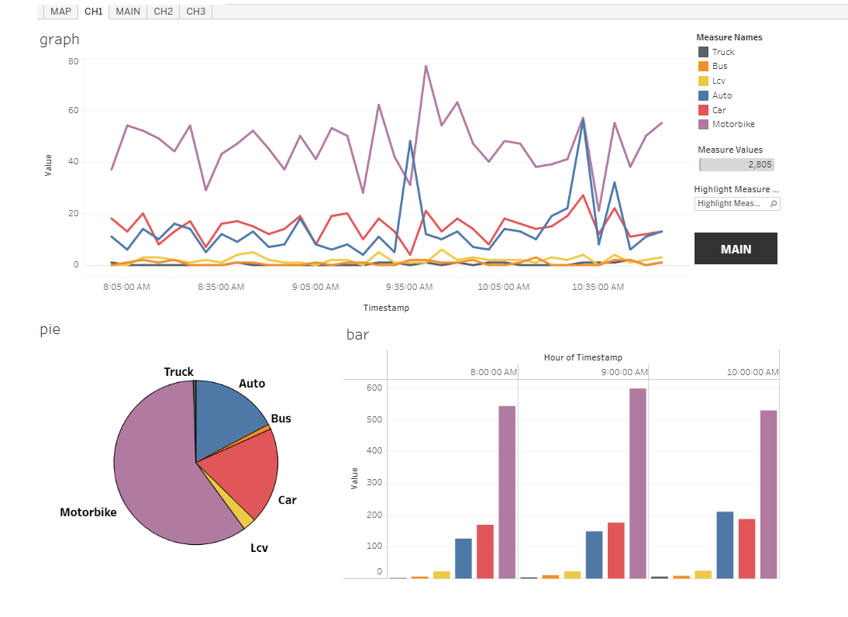
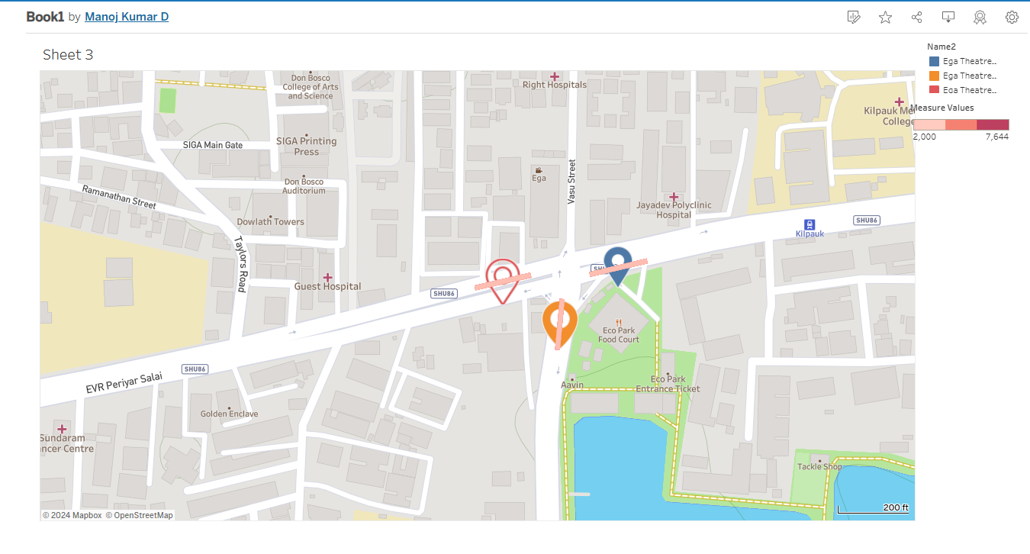

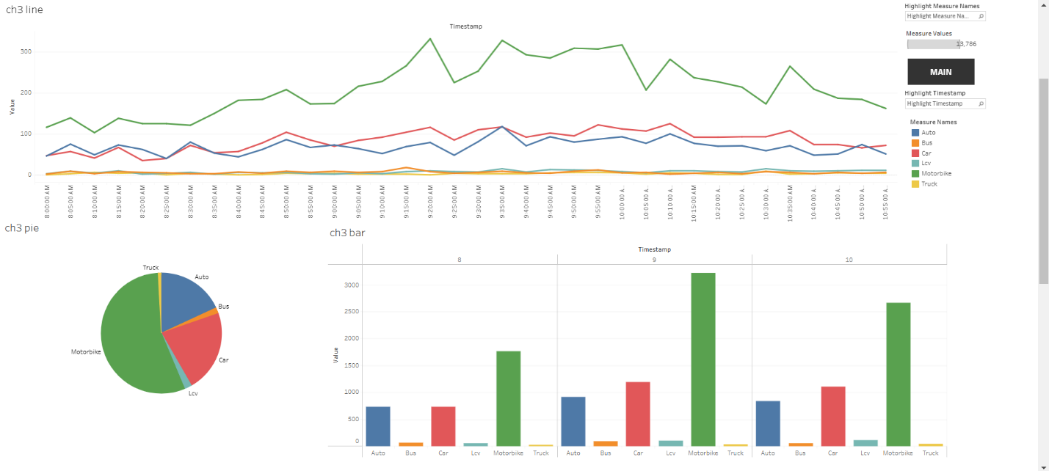

SECTION III
IMAGE ANNOTAION FOR VEHICLE DETECTION IN ROBOFLOW

Proposed Solution
The objective of the image annotation process was to label Indian vehicles captured from CCTV footage placed by Chennai Unified Metropolitan Transport Authority (CUMTA) near traffic signals. This process aimed to prepare a high-quality dataset for future AI applications, such as real-time traffic monitoring and automated vehicle detection. Using Roboflow, the annotation focused on classifying vehicles and pedestrians into predefined categories with polygonal precision to enhance model training accuracy.
The dataset consisted of 2,019 images, extracted from video frames recorded at traffic signals, representing real-world traffic scenarios. Vehicles and pedestrians were annotated with detailed polygon masks, ensuring precise object boundaries for improved machine learning outcomes.
.

Designed Methodology
• Dataset Preparation:
- Video footage was divided into frames using Python tools like OpenCV, ensuring evenly spaced intervals to cover diverse traffic scenarios.
- Extracted 2,019 frames with optimal resolution for clear visualization of objects.
- Uploaded the frames to Roboflow for annotation.
• Annotation Process:
- Using polygon annotation in Roboflow, objects were labeled to capture their exact shapes and boundaries.
- Annotations were classified into the following categories:
  - Ambulance
  - Auto
  - Bike
  - Bus
  - Car
  - College Bus
  - LCV
  - Pedestrian
  - Truck
- Each object’s label and polygon mask were saved with metadata for model compatibility.
• Quality Control:
- Reviewed annotations to ensure no mislabeling or missed objects.
- Verified bounding polygons for accuracy in representing objects’ edges.
- Removed duplicate or unclear frames from the dataset.
• Data Export:
- Exported annotated data in YOLOv5 formats, ready for training object detection models.

Features of Image Annotation
- Precise Polygon Annotations:
  - Polygon masks offered enhanced precision for irregularly shaped objects like trucks or pedestrians, making the dataset ideal for advanced AI models.
- Comprehensive Class Coverage:
  - Annotations included a diverse set of vehicle types and pedestrians, capturing real-world traffic variations.
- High-Quality Dataset:
  - The dataset featured 2,019 annotated images, representing a rich variety of urban traffic scenarios.
- Robust Annotation Platform:
  - Roboflow ensured efficient annotation with tools for zooming, masking, and batch processing.
- Scalable Dataset:
  - The dataset is suitable for training AI models to detect traffic participants in Indian urban environments, contributing to CUMTA’s mission of smart traffic management.
Class Name | Count
Ambulance | 42
Auto | 3,254
Bike | 11,809
Bus | 613
Car | 7,492
College Bus | 36
LCV | 773
Pedestrian | 500
Truck | 87

This process not only created a robust dataset for AI-driven traffic solutions but also reinforced the importance of detailed annotation in improving the accuracy of machine learning models for urban traffic management.
4.4PROTOTYPE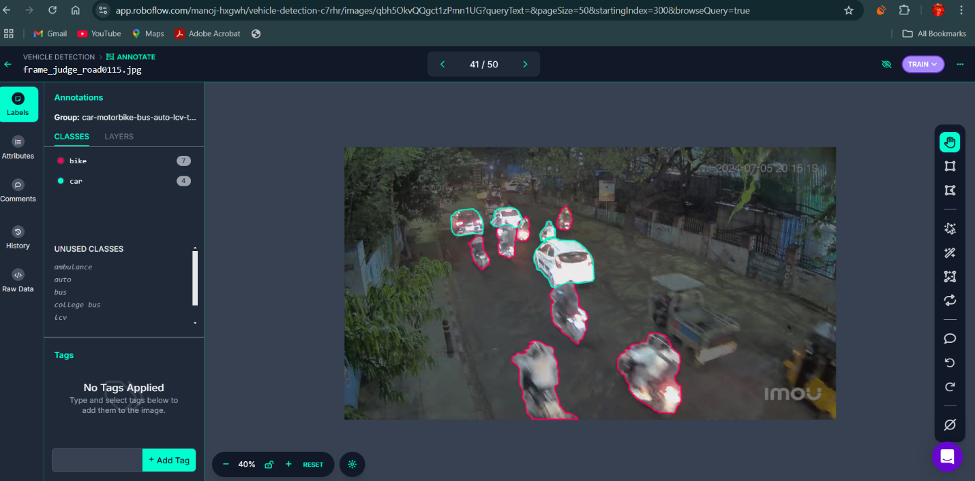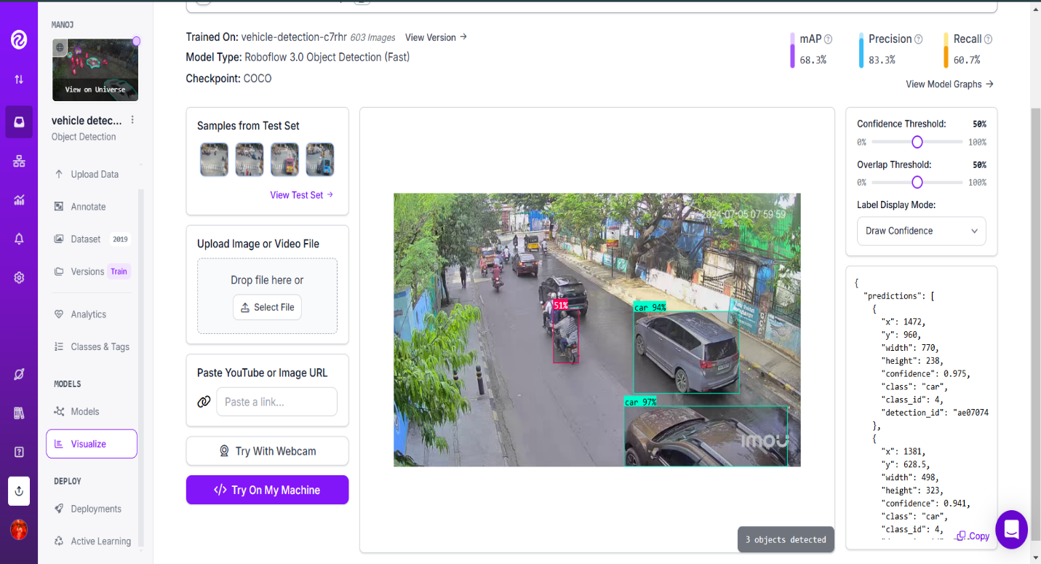
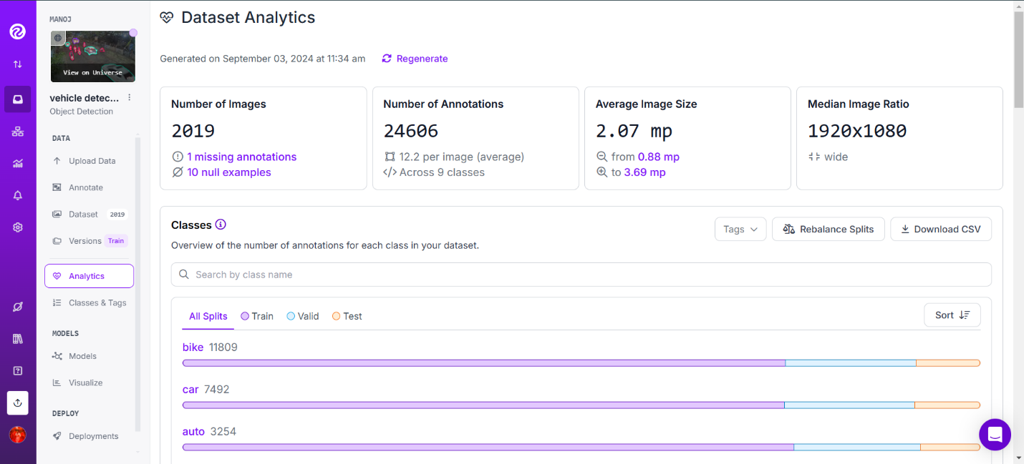
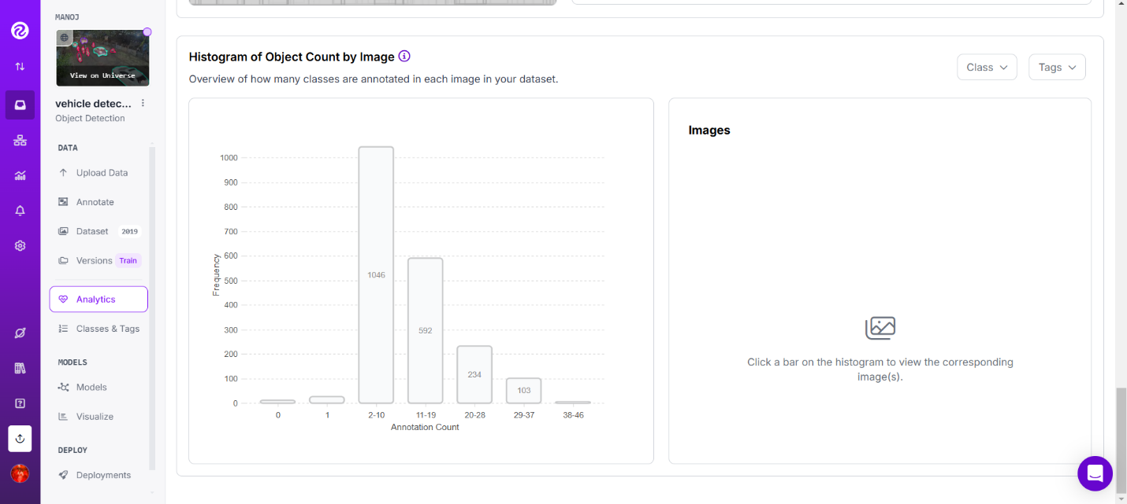

SECTION IV
DATA MANIPULATION AND CLEANING OF TRIRUVANNAMALAI BUS DEPO
Proposed Solution:
To address the objectives of the internship, a streamlined and structured solution was proposed, combining data processing, visualization, backend development, and AI readiness:
Data Manipulation and Cleaning:
Dataset Preparation: Loaded and inspected the Thiruvannamalai Bus Depot dataset using Jupyter Notebook and Python libraries.
Null Value Handling: Removed or imputed missing values in critical columns like arrival and departure times.
Bus Code Standardization: Applied corrections to bus codes for consistency.
Summarization: Aggregated data using functions like sum and count to calculate bus arrivals and departures.

CHAPTER – 6
IMPACT OF THE INTERNSHIP
The work carried out during the internship at Chennai Unified Metropolitan Transport Authority (CUMTA) has the potential to create a significant impact on urban traffic management in Chennai. By addressing key challenges in monitoring and analyzing traffic data, the project provides a foundation for smarter decision-making and improved mobility services.
The data manipulation efforts ensured the accuracy and reliability of traffic datasets. Clean and consistent data enables authorities to derive meaningful insights, which can be used to identify traffic patterns, peak congestion hours, and underutilized routes.
The interactive dashboard built using Tableau has transformed how traffic data is visualized. By providing real-time analytics through dynamic charts, the dashboard empowers decision-makers to monitor vehicular movement efficiently. For example, understanding vehicle count trends at specific signals can help in planning infrastructure upgrades, such as adding lanes or installing additional signals.
The development of a Flask-based backend system with MongoDB integration enhances the scalability and accessibility of traffic data. APIs developed during the internship allow seamless data retrieval and processing, ensuring that the system remains responsive even as traffic data volumes increase.
The image annotation component using Roboflow has a long-term impact by laying the groundwork for AI-driven traffic monitoring. Annotated datasets can be used to train machine learning models for vehicle detection and classification. Automated systems can reduce the manual effort required to monitor traffic, enabling real-time analysis and quicker responses to traffic incidents or congestion.
Overall, the project has contributed to CUMTA's mission of modernizing urban transport systems. It aligns with smart city initiatives, providing tools that integrate data-driven decision-making into traffic management. By leveraging modern technologies like Tableau, Flask, MongoDB, and AI tools, the project not only improves current processes but also paves the way for future innovations in urban mobility management. The work done has the potential to benefit not just Chennai but also other urban centers facing similar traffic challenges.
CHAPTER – 7
PROOF OF COMPLETION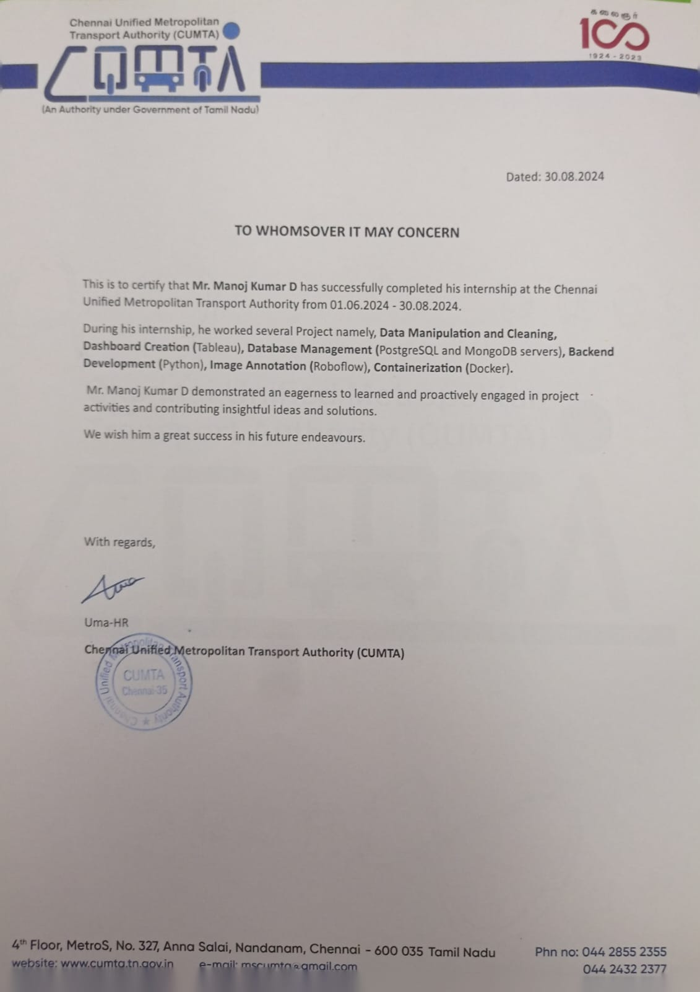

CHAPTER – 8
RESULT AND CONCLUSION
RESULT:
The internship at Chennai Unified Metropolitan Transport Authority (CUMTA) yielded significant results in the domain of urban traffic management, showcasing practical applications of data manipulation, visualization, backend development, and artificial intelligence. These efforts contributed to enhancing traffic analysis processes and provided a foundation for future advancements.
- Data Manipulation and Cleaning:
The data manipulation task resulted in a clean and structured dataset from the Tiruvannamalai Bus Depot. By addressing issues such as missing values, duplicates, and inconsistent formatting, the dataset became more reliable and ready for analysis. This step ensured that all subsequent operations and visualizations were based on accurate and actionable information.
- Interactive Dashboard with Tableau:
A dynamic and user-friendly traffic dashboard was developed using Tableau. The dashboard provided real-time insights into vehicular movement at various traffic signals using bar charts, line graphs, and pie charts. This tool enabled traffic management authorities to monitor trends, identify congestion hotspots, and make data-driven decisions for traffic flow optimization.
- Backend System Development:
The Flask-based backend, integrated with MongoDB, successfully created APIs to retrieve, process, and serve traffic data. The APIs were designed to handle real-time data requests, ensuring a responsive user experience. Additionally, the implementation of role-based access control provided a secure and scalable system that could differentiate between administrator and user privileges.
- Image Annotation Using Roboflow:
The image annotation process labeled thousands of vehicle images into predefined classes such as ambulances, buses, bikes, and pedestrians. This resulted in a high-quality dataset ready for training machine learning models for vehicle detection and classification. The annotated dataset is a valuable resource for future AI-driven traffic monitoring systems.

CONCLUSION:
The internship at Chennai Unified Metropolitan Transport Authority (CUMTA) provided a unique opportunity to apply theoretical knowledge to real-world challenges in urban traffic management. Through tasks involving data manipulation, dashboard creation, backend development, and image annotation, the project addressed key aspects of modernizing traffic analysis systems.
The manipulation and cleaning of the Tiruvannamalai Bus Depot dataset ensured the integrity and reliability of the data used for further processing and analysis. The Tableau dashboard, with its dynamic and visually engaging interface, transformed raw traffic data into actionable insights, empowering decision-makers to improve traffic flow and reduce congestion.
The development of a Flask-based backend, integrated with MongoDB, showcased the importance of scalable and secure data handling systems. Role-based authentication added a layer of customization and security, making the system robust and efficient. Additionally, the image annotation process using Roboflow set the stage for integrating AI into traffic monitoring, promising a future of automated and real-time analysis.
Overall, the internship resulted in a comprehensive solution that aligns with CUMTA's vision of leveraging technology for better urban mobility. The experience not only contributed to the organization’s objectives but also provided invaluable learning opportunities, preparing for future endeavors in smart city solutions and traffic management systems.

